Supplementary materials

Methods

Reagents, Antibodies and Primers
Cell culture was performed using BronchiaLife Epithelial Airway Medium Complete Kit (LL-0023, Lifeline Cell Technology, Carlsbad, CA, USA), Bronchial Epithelial Cell Growth Basal Medium (CC-3171) and Bronchial Epithelial Cell Growth Medium SingleQuots (CC-4175) from Lonza (Basel, Switzerland), and Corning® 12 mm Transwell® with 0.4 µm Pore Polyester Membrane Insert (3460, Corning, Corning, NY, USA). Gene knockdown used SERPINB2 siRNA (RiboBio, Guangzhou, China) and Lipofectamine RNAiMAX (13778150, Invitrogen, Carlsbad, CA, USA). Recombinant cytokines IFN-γ (285-IF), IL-13 (213-ILB), IL-17A (7955-IL), and tPA ELISA kit (DTPA00) were from R&D Systems (Minneapolis, MN, USA). Recombinant SERPINB2 (NBP2-35202), tPA (NBP2-59553) and d-dimer ELISA kit (NBP3-11720) were from Novus Biologicals (Centennial, CO, USA). Antibodies against SERPINB2 (1:1000 for WB, 1:500 for mIHC, 16035-1-AP) and GAPDH (1:10000, 60004-1-Ig) were from Proteintech (Rosemont, IL, USA), and tPA antibody (1:1000 for WB, 1:200 for mIHC, ab157469) was from Abcam (Cambridge, MA, USA). Real-time PCR primers were purchased from Sangon Biotech (Shanghai, China). Z-GGR-AMC (4002155) was from Bachem (Bubendorf, Switzerland).

Primary Nasal Epithelial Cell (NECs) Culture in Air–Liquid Interface (ALI).
Primary human nasal epithelial cells (HNECs) were collected by epithelia scraping of the IT or MT from healthy controls. Freshly harvested epithelial cells were placed directly into 10 mL of ice-cold PBS, centrifuged, washed, and resuspended in 1 mL of Lifeline BronchiaLife medium. A total of 1×10⁵ NECs were seeded into 60-mm tissue-culture dishes coated with type I collagen (Corning, Kennebunk, ME, USA) containing 3 mL of BronchiaLife Basal Medium with BronchiaLife Life Factors Kit supplementation. Cells were cultured at 37℃ in a 5% CO₂ environment. When epithelial cells reached around 90% confluence, they were dissociated with trypsin-EDTA and passed onto collagen-coated polyester Transwell inserts of 12 mm in diameter (pore size, 0.4 µm) at 4×10⁴ cells/cm2 and continued in serum-free Dulbecco modified Eagle medium/Bronchial Epithelial Cell Basal medium supplemented with insulin (4 mg/mL), transferrin (5 mg/mL), hydrocortisone (0.5 mg/mL), epinephrine (0.5 mg/mL), bovine hypothalamus extract (52 mg/mL), gentamicin (50 mg/mL), amphotericin (50 ng/mL), bovine albumin (0.5 mg/mL), ethanolamine (80 nmol/L), MgCl2 (0.3 mmol/L), MgSO4 (0.4 mmol/L), CaCl2 (0.1 mmol/L), retinoic acid (30 ng/mL), and recombinant epidermal growth factor (0.5 ng/mL).
On reaching 100% confluency, cells were shifted to ALI culture by removing all but 50 μL of the apical medium. From day 7 of ALI, cells are stimulated with IFN-γ, IL-13, IL-17A, SERPINB2 recombinant protein or medium alone added to the lower chamber for 48 hours. On day 9, cells were placed in 1mL TRIzol reagent for mRNA detection and in 300μL protein lysis buffer for WB analysis. Lower chamber supernatants were collected for tPA ELISA tests.

siRNA transfection of primary NECs under ALI stage.
siRNA transfection was performed using Lipofectamine RNAiMAX reagent. Briefly, siRNA was pre-mixed with 3 μl per well Lipofectamine RNAiMAX transfection reagent in Opti-MEM medium for 20 minutes at room temperature before being pooled together with NECs suspension and seeded onto transwell. The final concentration of SERPINB2 siRNA is 50nM. After 24 hours, the transfection mixture was removed and cells were switched to ALI culture. Cells were stimulated with or without IFN-γ or IL-13 under ALI culture for 48 hours.

Western Blotting (WB)
Fresh samples from HCs and CRSwNP patients and cultured cells were harvested in lysis buffer supplemented with Halt Protease Inhibitor Cocktail and Halt Phosphatase Inhibitor Cocktail (Thermo Fisher, Waltham, Mass). Volumes corresponding to 30μg protein were loaded and run on 10% SDS-PAGE Gel (EpiZyme Biotechnology). Proteins were transferred onto a nitrocellulose membrane (Pall Corporation) by using the eBlotTM L1 (GenScript). Membranes were blocked in 5% nonfat dry milk for at least 1 hour at room temperature and subsequently incubated overnight at 4℃ on a shaker with primary antibodies against SERPINB2 (1:1000 dilution), tPA (1:1000 dilution) and GAPDH (1:10000 dilution). After incubation with primary antibodies, the membranes were incubated with HRP-conjugated secondary antibodies for 1 hour at room temperature. The signals of the membrane were detected by chemiluminescence, and densitometric analysis was performed with ImageJ software.

qRT-PCR
Total RNA was extracted with TRIzol reagent (Invitrogen). A total of 1μg RNA was reverse-transcribed to cDNA using a Color Reverse Transcription Kit (A0010CGQ, EZBioscience, Los Angeles, CA, USA). Quantitative PCR was performed with the SYBR Green Ⅰ method by using Color SYBR Green qPCR Master Mix (ROX2 plus) (A0012-R2, EZBioscience, Los Angeles, CA, USA) with specific primers (Table E1). Amplification was as follows: 95 ℃ for 5 min, followed by 40 cycles of 95 ℃ for 10 sec, specific annealing temperature for 10 sec, and 60 ℃ for 30 sec. After PCR, a melting curve was constructed by increasing the temperature from 60 to 95 ℃ with a temperature transition rate of 0.11℃/s. Beta-glucuronidase (GUSB) was used as an internal control for normalization of gene expression. A normal inferior turbinate mucosal sample and a control cell culture sample were used as the calibrator for tissue samples and cell culture samples, respectively. An identical Ct was applied for each gene of interest. Relative mRNA expression was calculated by using the 2(-ΔΔCt) method.

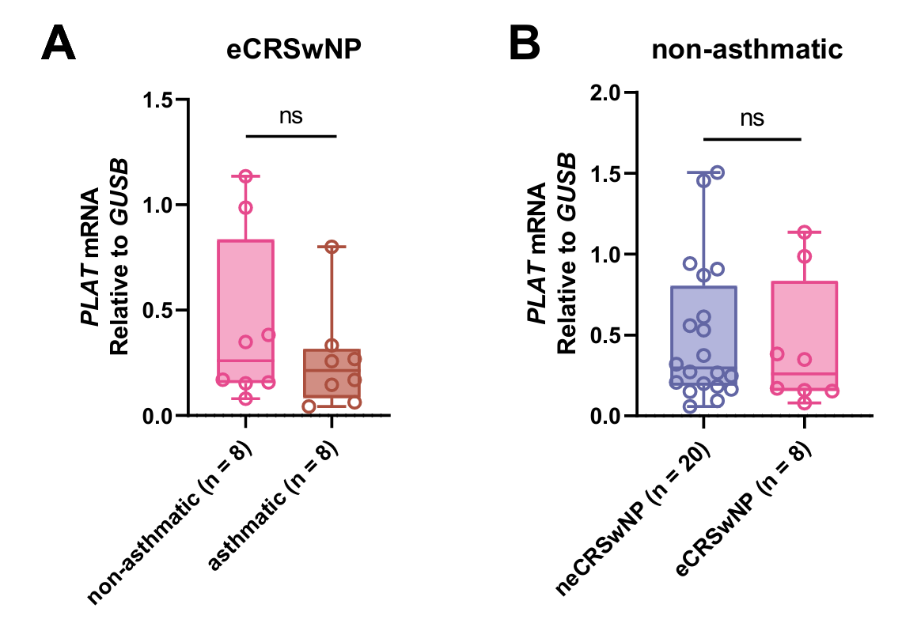
Supplementary Fig. 1. tPA expression is not affected by asthma comorbidity. (A) PLAT mRNA levels in asthmatic vs. non-asthmatic eCRSwNP patients. (B) PLAT mRNA levels in non-asthmatic patients stratified by endotype. ns, not significant.

Supplementary Fig. 2. SERPINB2 knockdown efficiency validation. (A) Representative western blot showing SERPINB2 protein expression in primary nasal epithelial cells transfected with negative control (NC) siRNA or SERPINB2 siRNA. (B) Quantitative analysis of SERPINB2 protein levels was performed based on three independent biological replicates and normalized to GAPDH. *p < 0.05 vs. NC.

Supplementary Table 1. Characteristics and methods.
 | HC | neCRSwNP | eCRSwNP | p Value
Subject number | 20 | 25 | 20
Tissue used | IT or MT | NP | NP
Age (mean ± SD) | 44.28 ± 14.12 | 45.33 ± 16.03 | 41.19 ± 15.98 | 0.661
Gender (M/F) | 13/7 | 16/9 | 14/6 | 0.907
Asthma (Y/N) | 0/20 | 2/25 | 8/20 | 0.010
PBE counts (× 10⁹/L) (mean ± SD) | 0.13 ± 0.11 | 0.25 ± 0.14 | 0.48 ± 0.21 | 0.000
JESREC score (≥11/<11) | - | 1/24 | 18/2
Methodologies used, number
Tissue RNA | 18 | 22 | 16
Tissue IF | 8 | 8 | 8
Tissue WB | 9 | 9 | 9
Cell culture | 6 | 0 | 0

HC, healthy control; neCRSwNP, non-eosinophilic chronic rhinosinusitis with nasal polyps; eCRSwNP, eosinophilic chronic rhinosinusitis with nasal polyps; MT, ethmoid mucosa; IT, inferior turbinate; NP, nasal polyp; F, female; M, male; PBE, peripheral blood eosinophil

Supplementary Table 2. Primers used in quantitative PCR analysis for human tissues.

Gene name |  | Primer
SERPINB2 | Forword | CAGCACCGAAGACCAGATGG
SERPINB2 | Reverse | CCTGCAAAATCGCATCAGGATAA
PLAT | Forword | AAACCCAGATCGAGACTCAAAGC
PLAT | Reverse | GGTAGGCTGACCCATTCCC
IFNG | Forword | TCGGTAACTGACTTGAATGTCCA
IFNG | Reverse | TCGCTTCCCTGTTTTAGCTGC
CLC | Forword | TCTACTGTGACAATCAAAGGGC
CLC | Reverse | CACGACGACCAAAGCACAC
IL17A | Forword | AGATTACTACAACCGATCCACCT
IL17A | Reverse | GGGGACAGAGTTCATGTGGTA
GUSB | Forword | GTCTGCGGCATTTTGTCGG
GUSB | Reverse | CACACGATGGCATAGGAATGG

